1. Build/Run the Program without debugging

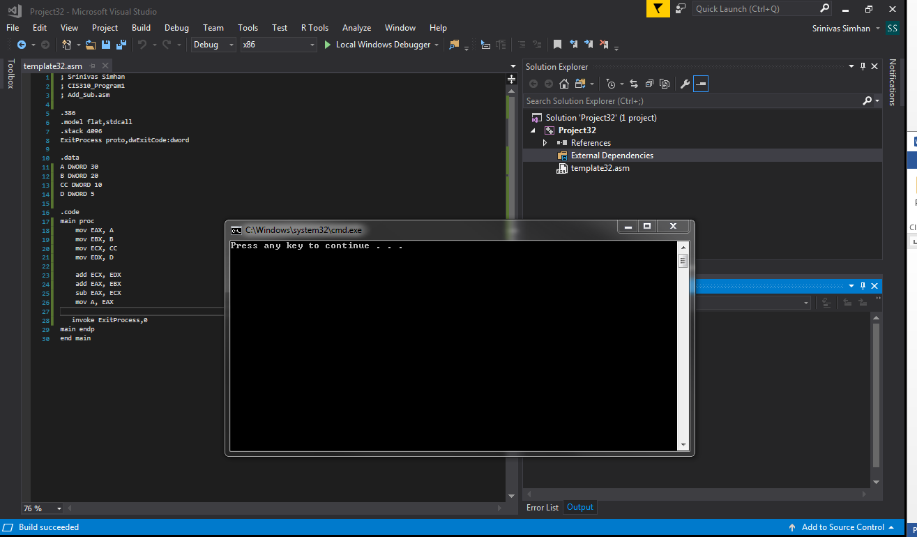

1. Run the program in the debugging mode and add the register window to a debugging session

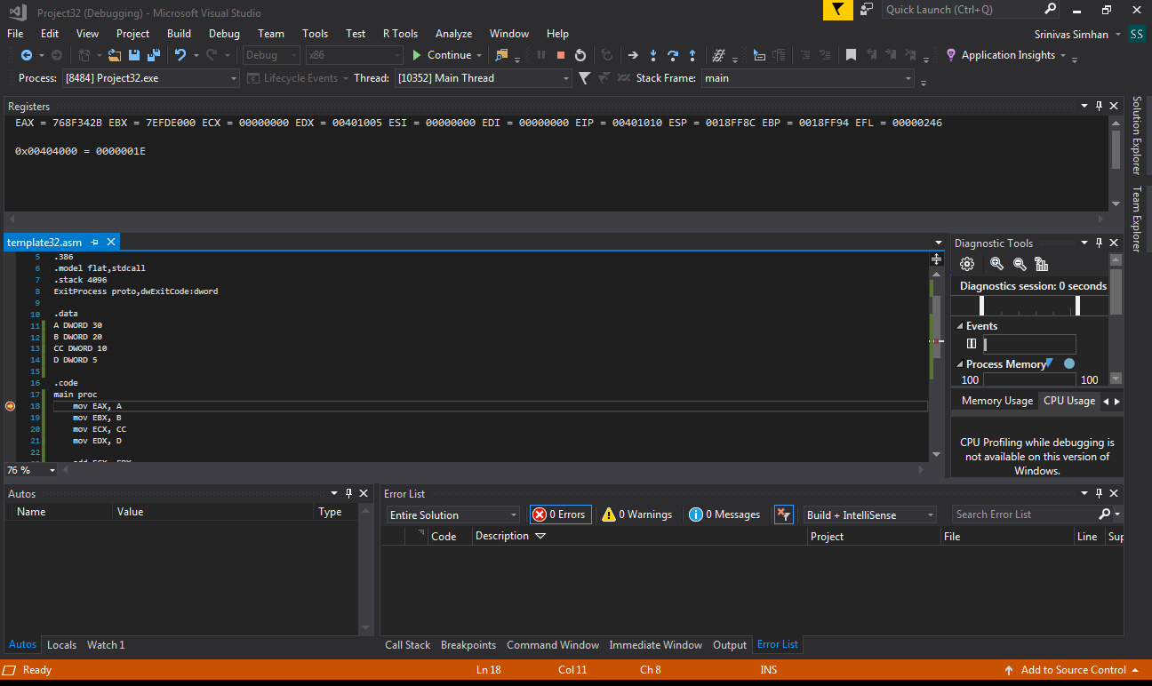

1. Generate the listing file

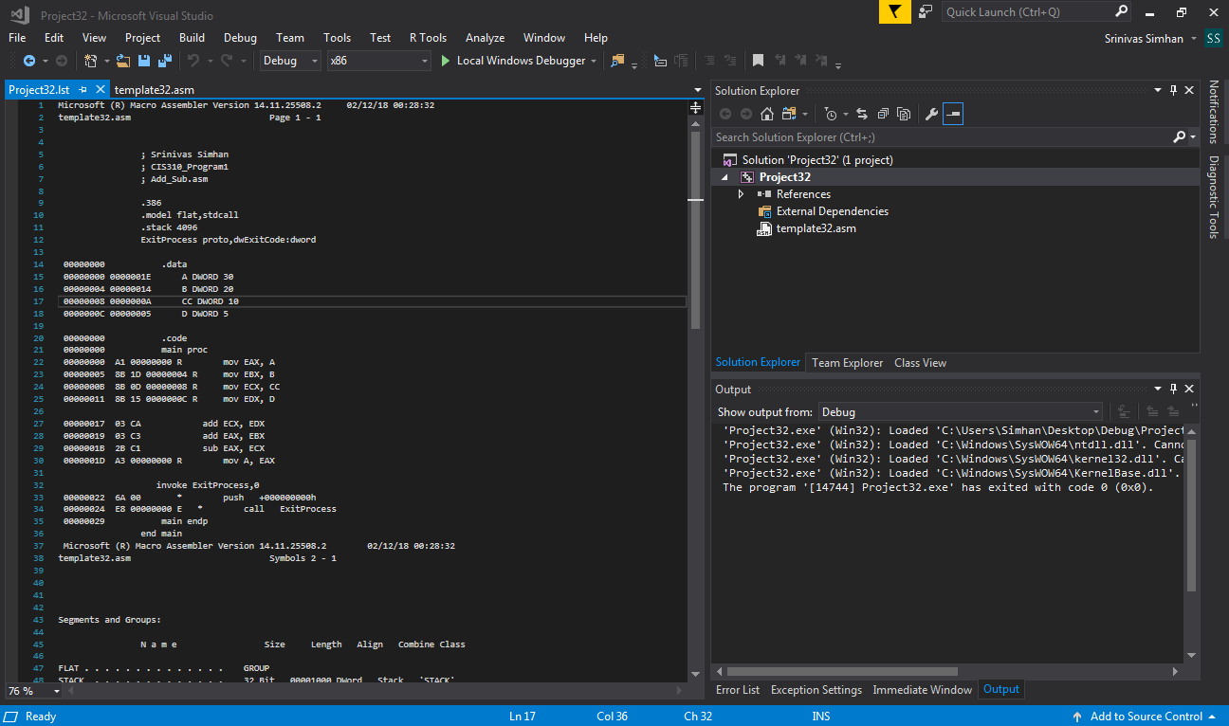

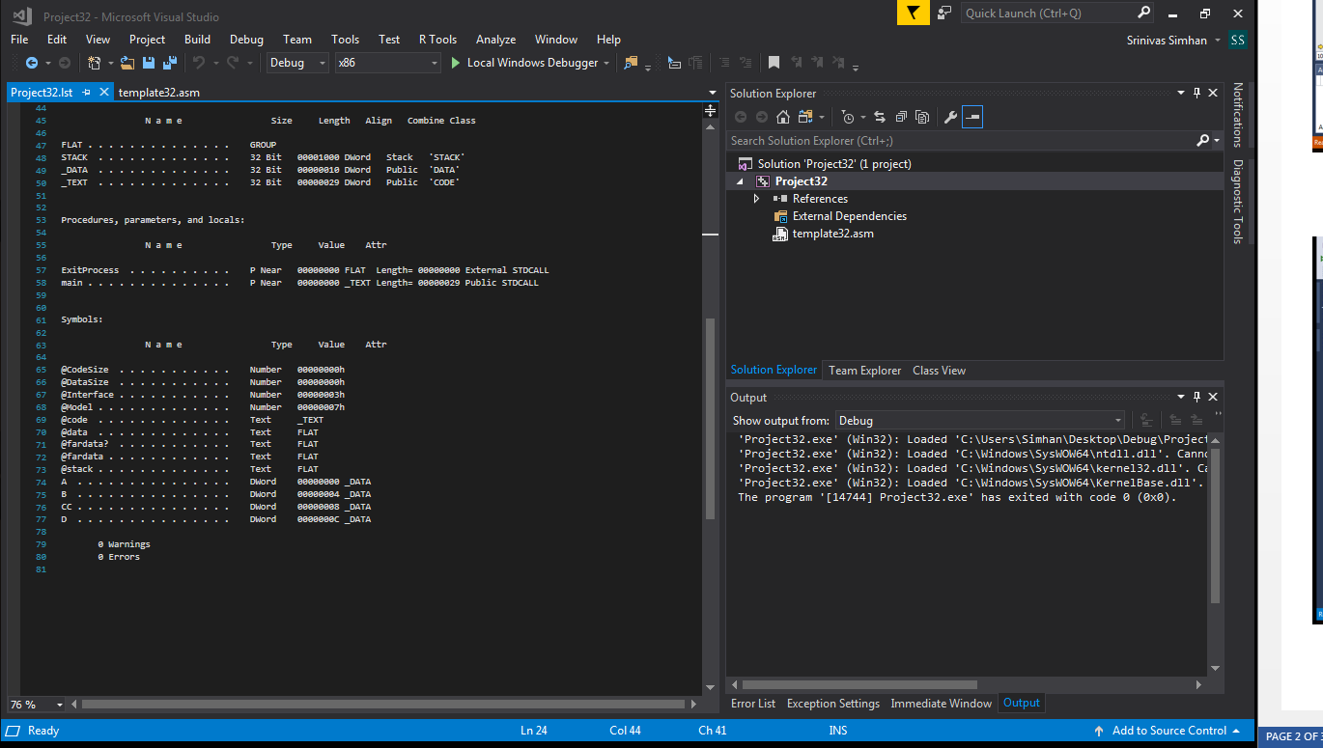

Code

; Srinivas Simhan

; CIS310_Program1

; Add_Sub.asm

.386

.model flat,stdcall

.stack 4096

ExitProcess proto,dwExitCode:dword

.data

A DWORD 30

B DWORD 20

CC DWORD 10

D DWORD 5

.code

main proc

mov EAX, A

mov EBX, B

mov ECX, CC

mov EDX, D

add ECX, EDX

add EAX, EBX

sub EAX, ECX

mov A, EAX

invoke ExitProcess,0

main endp

end main